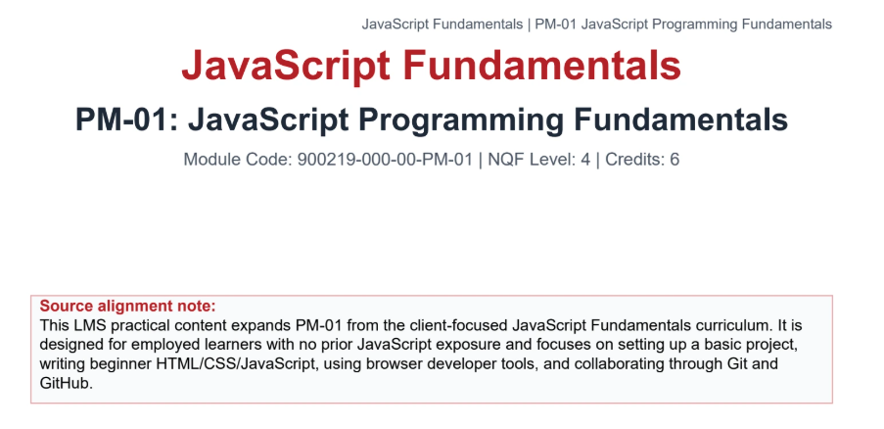

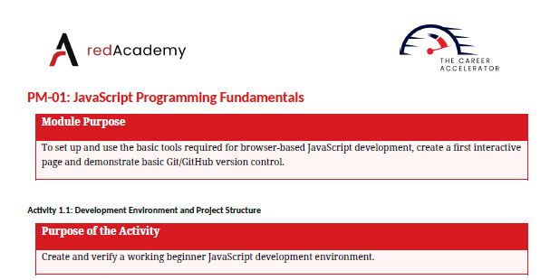

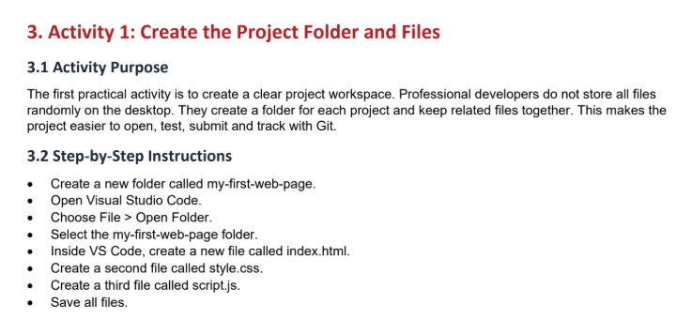

Activity 1 :
Create a new folder called my-first-web-page
Open Visual Studio Code: Choose File > Open folder
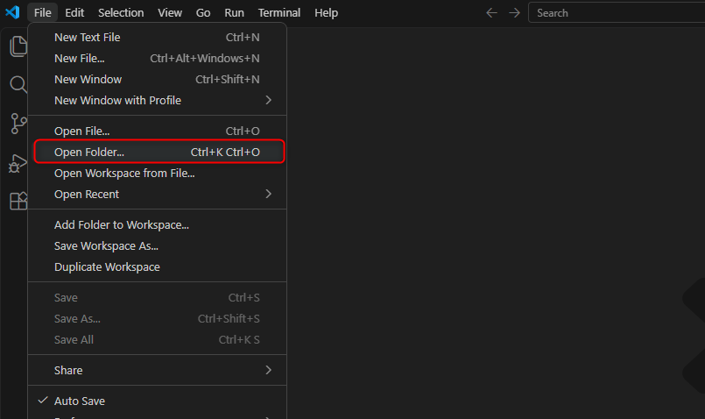
Select my-first-web-page folder
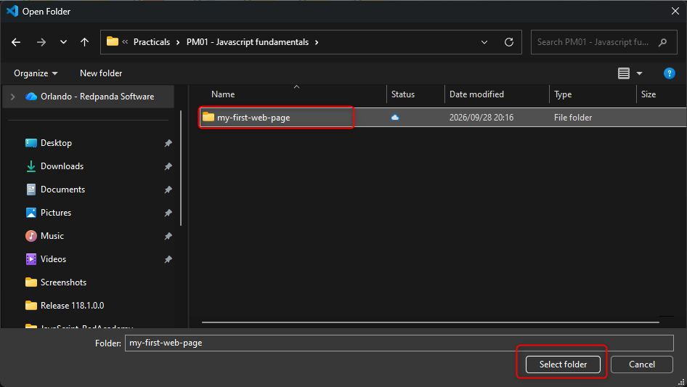
Create new file called index.html
Create a second file called style.css
Create a third file called script.js
Save all files.
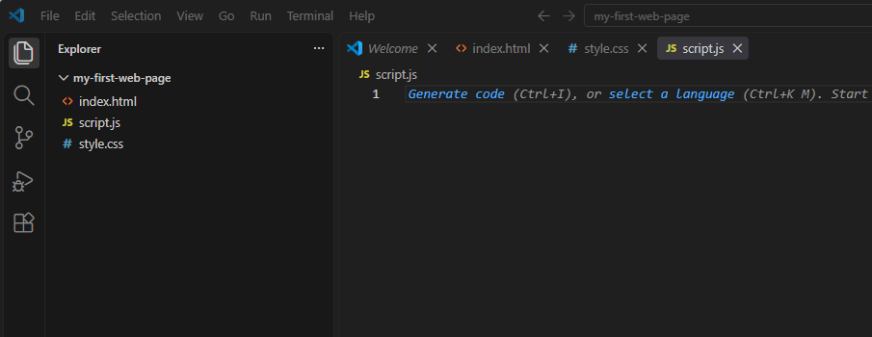
Run the program in web browser and observe the developer tools and the console and elements tabs:
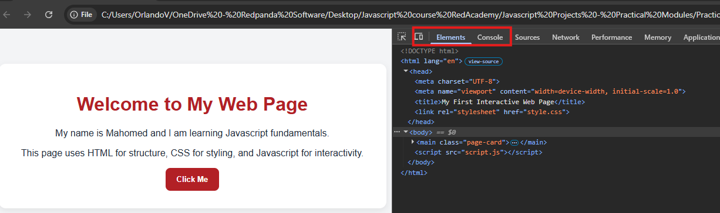
_________________________________________________________________________________
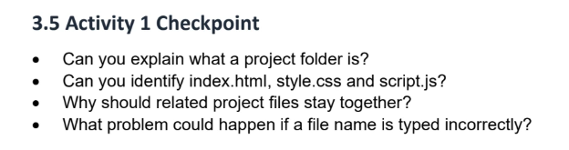
Can you explain what a project folder is?
A project folder helps keep file organisation neat and tidy. The folder holds all related files in one location for easier reference and use.
Can you identify index.html, style.css and script.js?
index.html is a file which holds contains the page structure and html elements that exist on the page. Style.css is the cascading style sheets, this helps decorate or add styling to the appearance of the page. Script.js holds the javascript code which ads functionality to the web page.
Why should related project files stay together?
This is important because it teaches organisation and makes it easier to troubleshoot the project.
What problem could happen if a file is typed incorrectly.
If the file name is misspelt, when trying to link the file there will be a mis-match and the styling nor javascript code will work. The file names need to be an exact match.
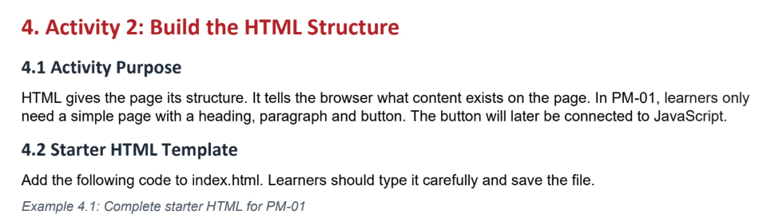
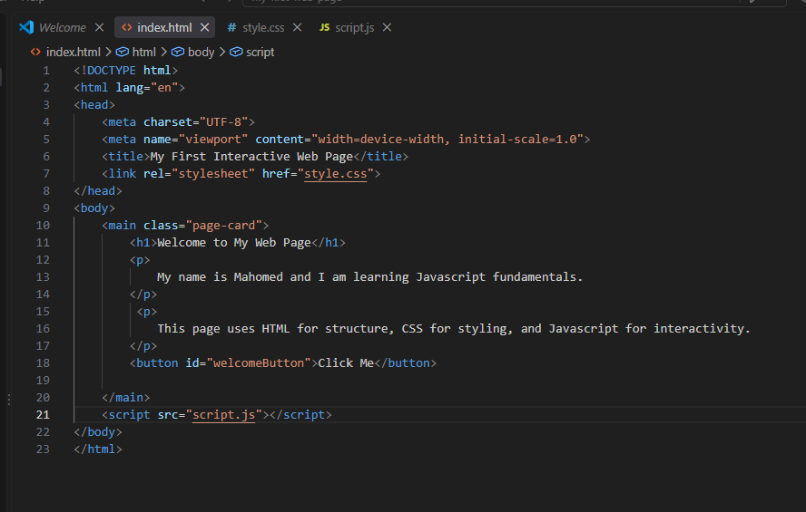
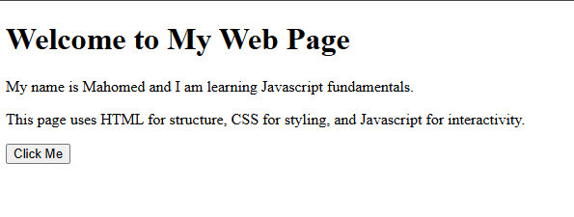
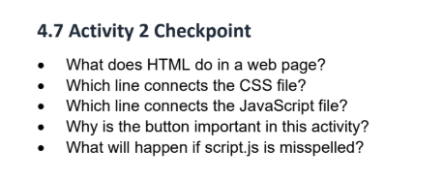
What does HTML do in a web page?
HTML builds the structure of the page using elements.
Which line connects the CSS file?
<link rel=’stylesheet’ href=’style.css’> this must be placed in the head section of the page structure. It’s important to remember the file name has to be the same.
Which line connects the Javascript?
<script src=’script.js’></script> It’s important to remember the file name has to be the same.
Why is the button important in this activity?
The button will interact with javascript code and will demonstrate how events trigger javascript code execution.
What will happen if script.js is misspelled?
If the file name is misspelled or not matching in the linking script there will be a mismatch and the javascript file will not be linked and therefore the javascript code will not take effect in the html page when it runs.
________________________________________________________________________________
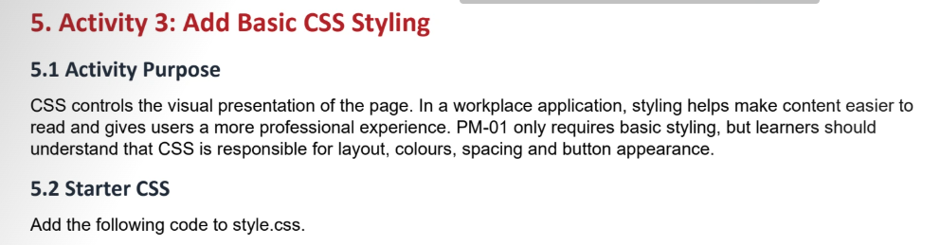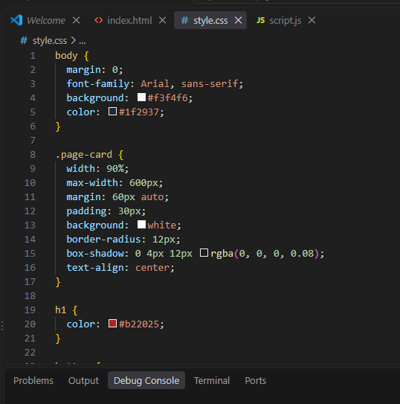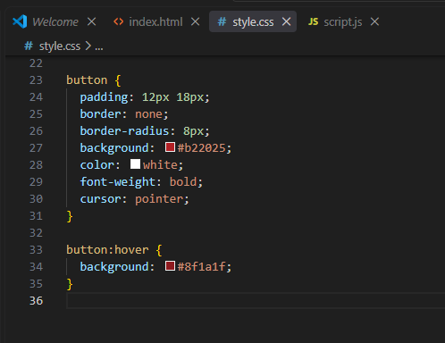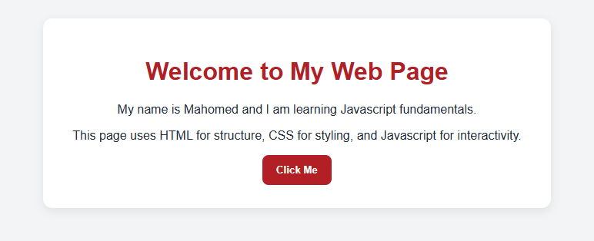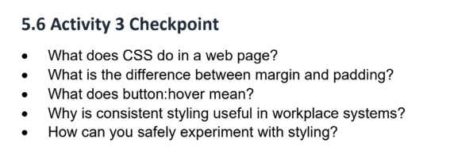
What does CSS do In a web page?
CSS controls the visual representation of the page. Styling helps make content easier to read and gives users a more professional experience.
What is the difference between margin and padding?
Margin creates space around the element on all sides. Padding adds space inside the element around its content.
What does button:hover mean?
When the cursor is moved over the button the user can specify an action. Typically, the user would change the buttons styling (change it’s colour) when the cursor focus is on the button.
Why is consistent styling useful in workplace systems?
Good styling makes a page easier to read, helps users understand what to click, and supports a professional impression. In business systems, confusing styling can lead to user mistakes, missed information or poor adoption of an internal tool.
How can you safely experiment with styling?
Experiment by changing one or two values to observe the result. Changing to many values could result in the user losing track of what the change actually does.

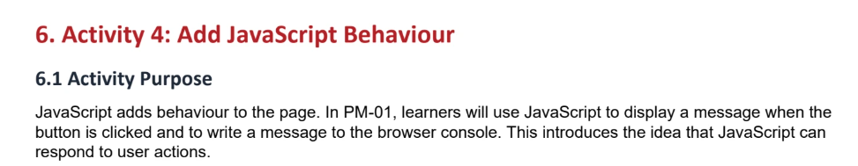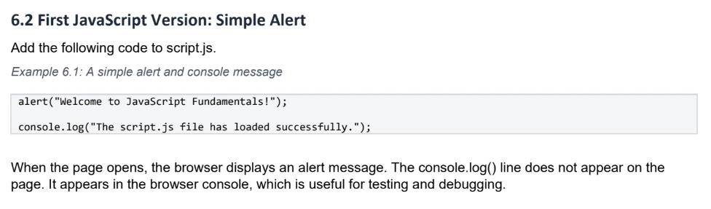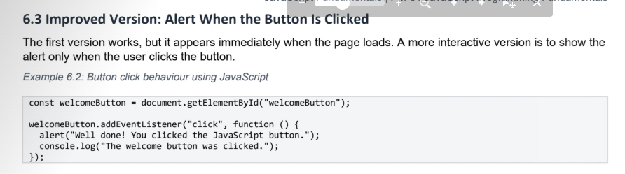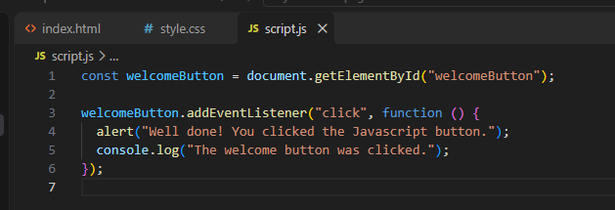
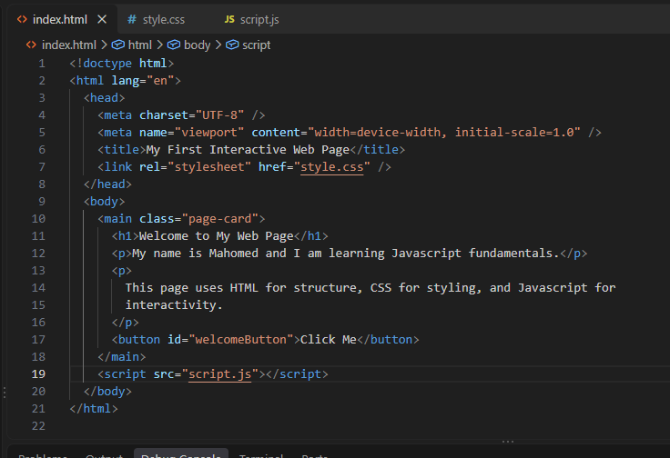
Run the application: Before button click
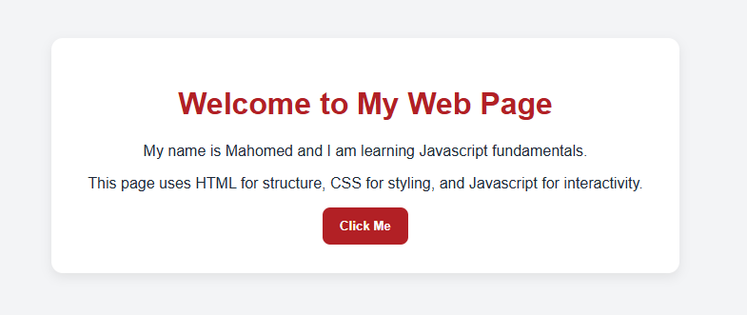
Click the button:
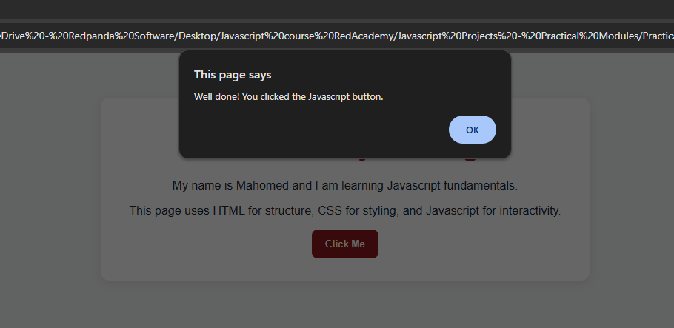
Observe console log message:
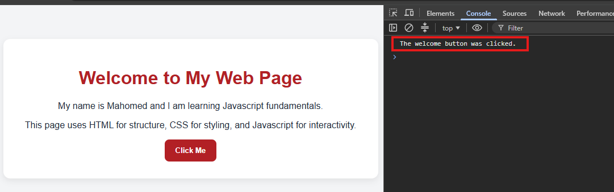
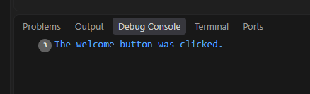
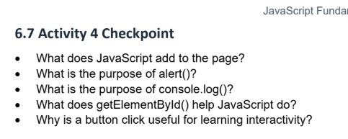
What does Javascript add to the page?
Javascript adds functionality and interactivity to the page. It allows users to effect certain outcomes based on events. Eg: click a button to display a message.
What is the purpose of an alert()?
The alert method allows for a message to appear that displays in the browser.
What’s the purpose of console.log()?
Console.log() is used primarily to store a message relating to an operation that took place. Generally, it is used to log a message that would assist with debugging the application.
What does getElementById() help Javascript do?
This is a method that identifies an HTML element with an ID property that matches the name in the parameter list of the method. This is helpful when trying to display information on the executed program in the rendered page with DOM.
Why is a button click useful for learning interactivity?
It’s useful because it allows a user to perform a click event that in turn will produce a particular specified outcome.
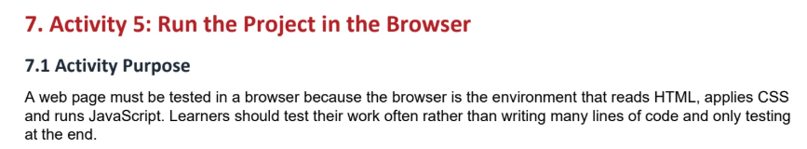
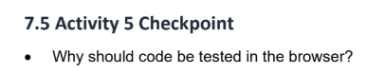
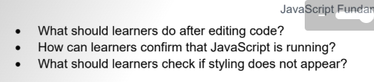
Why should code be tested in the browser?
A web page must be tested in the browser because the browser is the environment that reads HTML, applies CSS and runs Javascript. Devs should test their work often.
What should learners do after editing code?
Learners should save their work, then run the program. Without saving the changes will not take effect when the program runs.
How can learners confirm that javascript is running?
Learners can confirm javascript is running by makin sure the script tag is linked correctly. Thereafter, by effecting an event, clicking a button to display a message or by checking the developer tools, either for a console message or the sources tab.
What should learners check of styling does not appear?
Firstly, learners should confirm proper linking of the CSS file. Secondly verify the correct naming of the file and file reference.
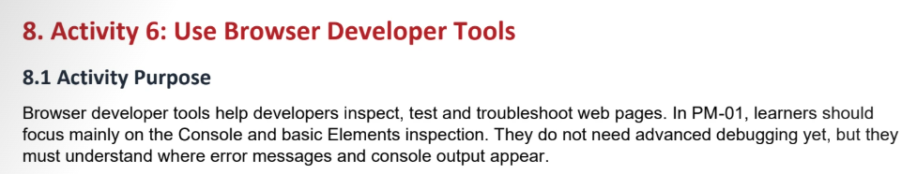
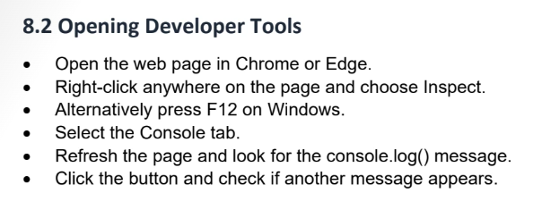
Inspect:
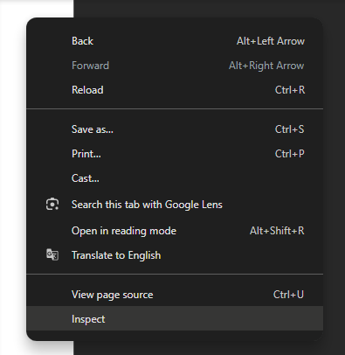
F12:
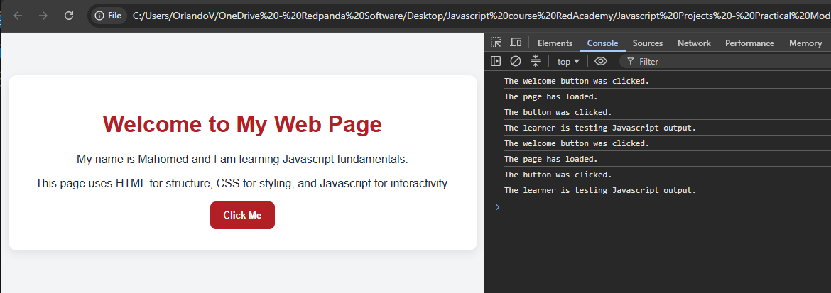
Click button again and observe new console messages:
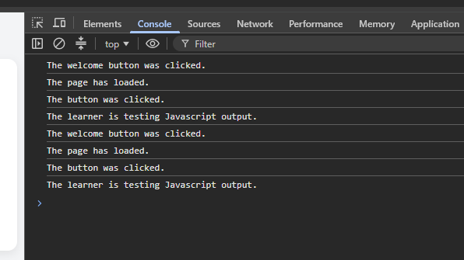
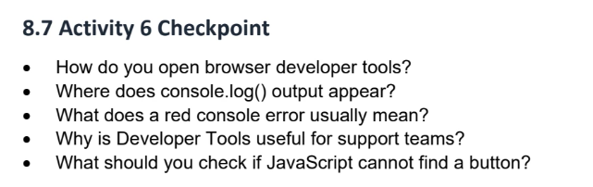
How do you open browser developer tools?
To open browser developer tools, right click anywhere on the web page and select ‘inspect’. Alternatively, when the web page is running press F12.
Where does the console.log() output appear?
The console.log() output shows on the console tab in the developer tools.
What does the red console error usually mean?
It usually means that javascript encountered an error and cannot complete something.
eg: a 404 error means the file cannot be found
Why is developer tools useful for support teams?
Support teams can capture console errors, network symptoms and reproduction steps. Devops can confirm whether a frontend deployment is serving the expected files.
What should you check if Javascript cannot find a button?
I would first check how the javascript source file is linked. I would check the tags and then the src file name.

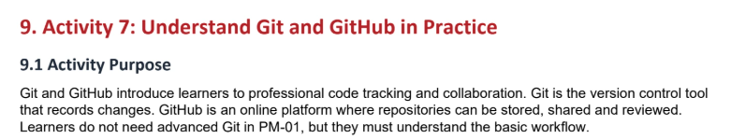

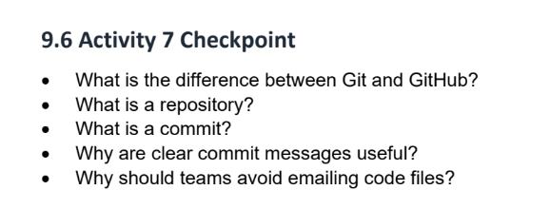
What is the difference between Git and GitHub?
Git is a version control system. It helps with tracking files and changes to those files. GitHub is a cloud application used to store file repositories/projects and allows for collaboration between various developers.
What is a repository?
A repository is a folder that stores project files. A project storage area that contains code and history.
What is a commit?
A saved snapshot of changes with a message.
Why are clear commit message useful?
It helps explain what changed. A commit message should be short but clear to understand the purpose of the commit/change.
Why should teams avoid emailing code files?
People may lose track of the latest or most up to date version, lose track of changes, over write versions or struggle to review what changed.

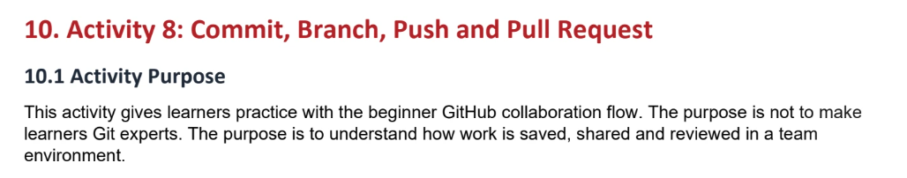
Git init:
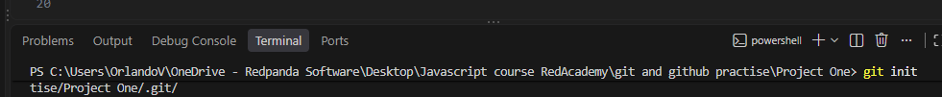
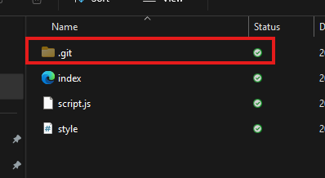
Git status:
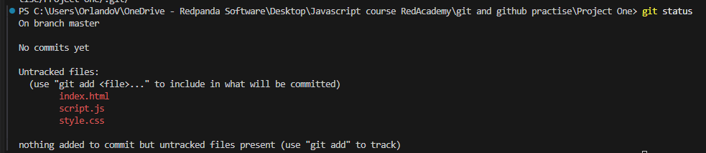
Git add .:
Git status:
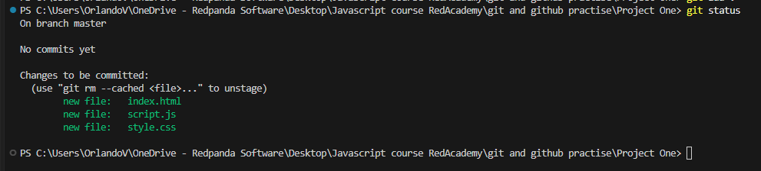

Git commit -m “Create my Project One repo”
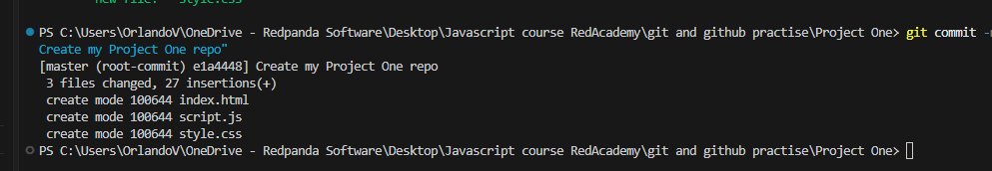
Git checkout -b add-paragraph-id-newPara
New change:
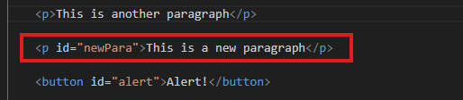
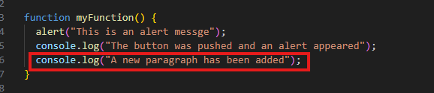
Git status:
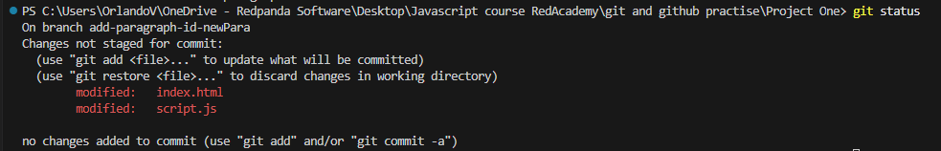
Git add .

Git status:
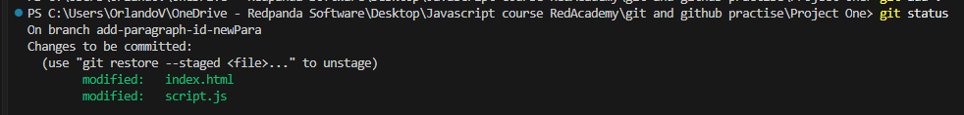

Git commit -m “added paragraph and new console message”
Git remote add origin
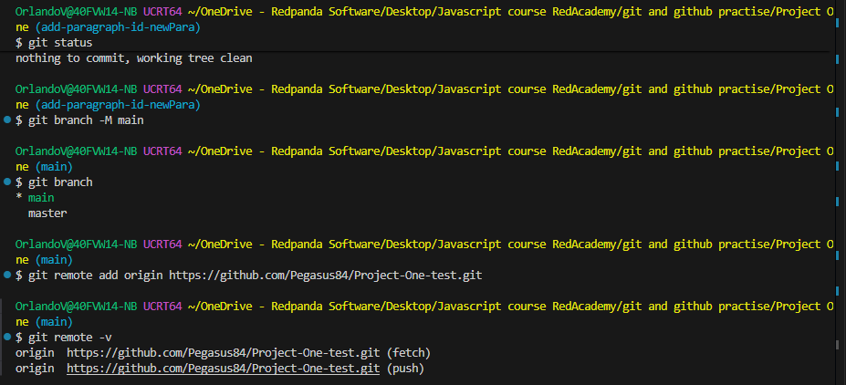
Git pull origin main –allow-unrelated-histories
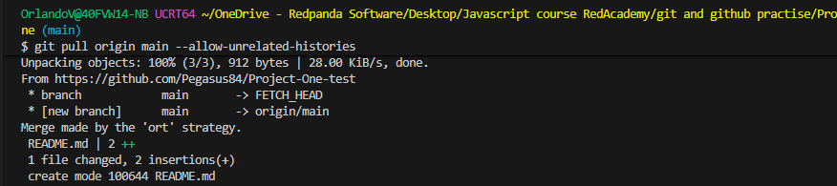
Git push:
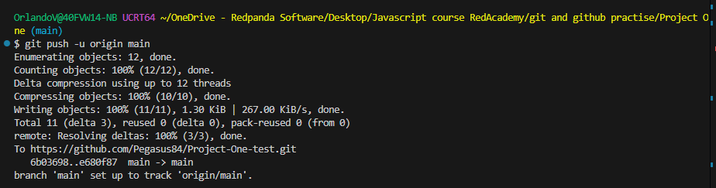

GitHub – create a repository: Add readme file
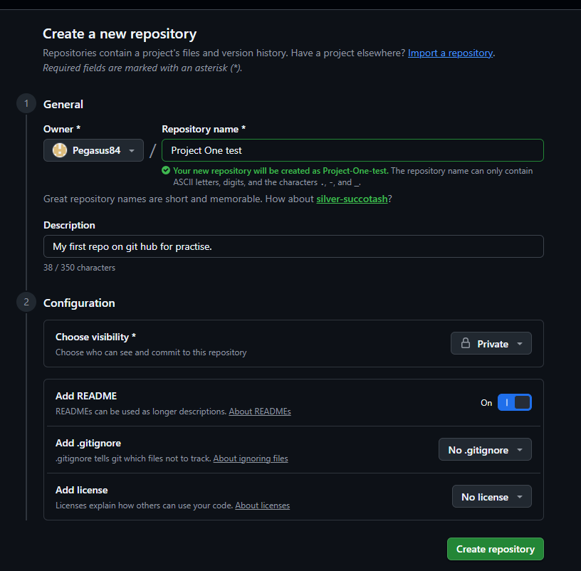
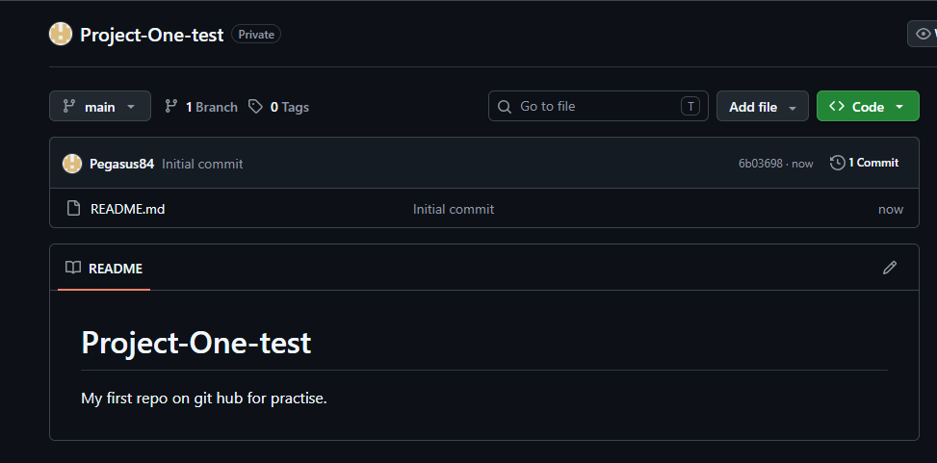
GitHub history:
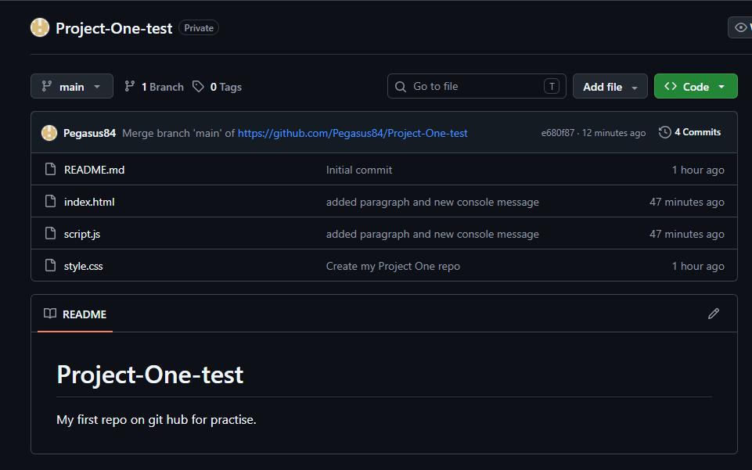

Project folder:
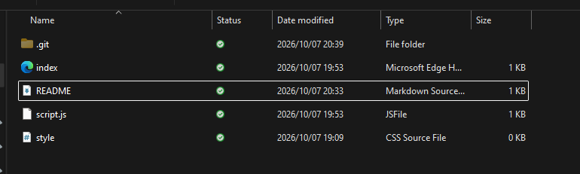
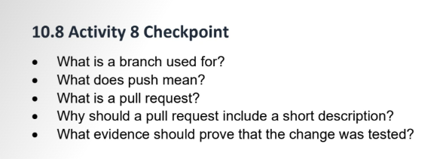
What Is a branch used for?
It s a separate place to make changes safely without effecting the main code in the project.
What does push mean?
It means to send local commits to github.
What is a pull request?
Bring changes from github to your computer.
Why should a pull request include a short description?
Is a request for others to review and merge changes. It explains why the change was made, what changed how it was tested.
What evidence should prove that the change was tested?
A screenshot of page, console output and repository commits.

